Von Neumann Architecture
Von Neumann architecture is a computer design where instructions and data are stored in the same memory space. This means the CPU fetches both instructions and data from the same memory, using the same pathways. Historically there have been 2 types of Computers:
- Fixed Program Computers - Their function is very specific, and they couldn't be reprogrammed, e.g., calculators.
- Stored Program Computers - These can be programmed to carry out many different tasks; applications are stored on them, hence the name.
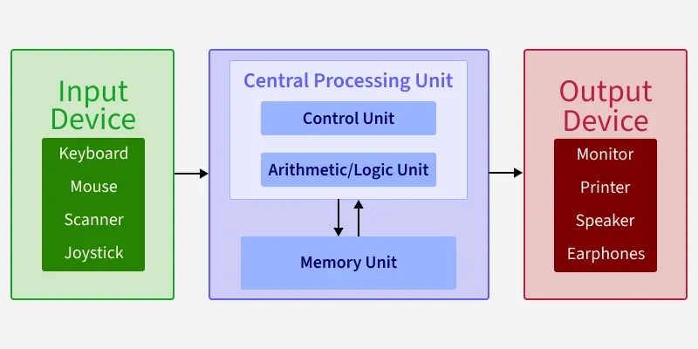

Components of Von Neumann Architecture
The structure described in the figure outlines the basic components of a computer system, particularly focusing on the memory and processor. It is made up with three main components:
- CPU
- Memory
- I/O Devices
We have these 3 components lets us see more about them in detail:
CPU (Central Processing Unit)
The central processing unit (CPU) is the main part of a computer that controls how it works. It is made up of the control unit, the arithmetic logic unit (ALU) and Registers (not RAM). The CPU handles instructions from programs, processes data, stores information, and produces results. Without the CPU, a computer cannot perform tasks or run any applications.
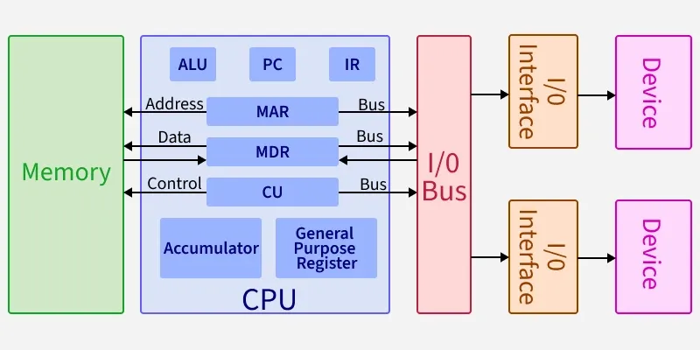

CU (Control Unit)
The control unit manages how the processor works by sending control signals. It decides how data should move inside the computer, controls input and output operations, and fetches the instructions from memory for execution.

ALU (Arithmetic and Logic Unit)
The arithmetic and logic unit is the part of the CPU that handles the calculations and decision-making tasks. It performs arithmetic operations like addition and subtraction, logical operations such as comparisons, and tasks like shifting bits in data.

Registers
Registers are the fastest type of memory located inside the CPU. They temporarily store information that the processor is currently working on, making program execution and operations faster and more efficient. Register serve as the CPU's primary working memory.
- PC (Program Counter): Keeps track of the address of the next instruction to be executed.
- IR (Instruction Register): Holds the current instruction being executed.
- MAR (Memory Address Register): Stores the address of the memory location being accessed.
- MDR (Memory Data Register): Temporarily holds data being transferred to or from memory.
- Accumulator: A register that stores intermediate results of arithmetic and logic operations.
- General Purpose Registers: Used for temporary storage of data during processing.

Bus
The bus is a communication system that transfers data, addresses, and control signals between the CPU, memory, and I/O devices. In Von Neumann architecture, a single bus is shared for both data and instructions, which can create a bottleneck (known as the Von Neumann bottleneck).

I/O Bus
- I/O Interface: Connects the CPU and memory to input/output devices.
- Device: Refers to external hardware like keyboards, monitors, or storage devices.

Key Characteristics
- Single Memory for Data and Instructions: Both data and program instructions are stored in the same memory.
- Shared Bus: A single bus is used for transferring data, addresses, and control signals, which can limit performance.
- Sequential Execution: Instructions are executed one at a time in a sequential manner.

Von Neumann bottleneck
Whatever we do to enhance performance, we cannot get away from the fact that instructions can only be done one at a time and can only be carried out sequentially. Both of these factors hold back the competence of the CPU. This is commonly referred to as the 'Von Neumann bottleneck'. We can provide a Von Neumann processor with more cache, more RAM, or faster components but if original gains are to be made in CPU performance then an influential inspection needs to take place of CPU configuration.

Applications
Von Neumann architecture is the foundation of most modern computing systems, where both instructions and data are stored in the same memory. Here are the some applications:
- Personal Computers and Laptops: Most PCs and laptops (Intel/AMD) use a shared memory that stores both programs and data, enabling efficient running of software like Windows and browsers. Example: Intel Core i7, AMD Ryzen processors.
- Smartphones and Tablets: ARM-based devices use the shared memory model to support multitasking and power efficiency in apps on iOS and Android. Example: Qualcomm Snapdragon, Apple A-series chips
- Embedded Systems:Microcontrollers in cars, IoT devices, and appliances use Von Neumann architecture for simple, cost-effective processing of instructions and data in the same memory. Example Arduino Uno (ATmega328), older ARM Cortex-M designs.
- Servers and Cloud Computing: Servers utilize shared memory systems to handle large-scale software and data tasks for services like AWS and Netflix.
- Gaming Consoles: Consoles like PS5 and Xbox use unified memory to run game code and manage inputs, enabling smooth gameplay.

1. Memory-Addressing Instruction (LOAD 0x10)
This instruction loads data stored at RAM address 0x10 into the Accumulator.
- Fetch Phase:
  - PC sends address 0x00 -> MAR.
  - RAM responds over the bus -> MDR receives byte LOAD 0x10.
  - MDR routes byte -> IR. (PC increments to 0x01).
- Decode Phase: The Control Unit decodes the opcode (LOAD) and extracts memory address 0x10 from the IR's operand field.
- Data / Execute Phase:
  - IR passes target address 0x10 -> MAR.
  - RAM returns data value 5 over the bus -> MDR.
  - MDR routes data value 5 -> Accumulator.
- RAM Accesses: 2 total (1 for instruction, 1 for data).
2. Immediate Instruction (ADD #5)
This instruction adds the constant value 5 (embedded directly in the instruction) to the Accumulator.
- Fetch Phase:
  - PC sends address -> MAR.
  - RAM responds over the bus -> MDR receives byte ADD #5.
  - MDR routes byte -> IR. (PC increments).
- Decode Phase: The Control Unit decodes opcode (ADD) and extracts the constant value 5 sitting directly inside the IR operand field.
- Data / Execute Phase:
  - IR routes value 5 directly into the Arithmetic Logic Unit (ALU).
  - ALU adds 5 to current Accumulator value.
- RAM Accesses: 1 total (data is already inside the IR; no second RAM fetch is needed).
3. Register-to-Register Instruction (ADD R1, R2)
This instruction adds the value in register R2 to register R1.
- Fetch Phase:
  - PC sends address -> MAR.
  - RAM responds over the bus -> MDR receives byte ADD R1, R2.
  - MDR routes byte -> IR. (PC increments).
- Decode Phase: The Control Unit decodes opcode (ADD) and identifies internal registers R1 and R2.
- Data / Execute Phase:
  - CPU transfers values from R1 and R2 directly to the ALU inside the processor.
  - ALU computes sum and writes output back to R1.
- RAM Accesses: 1 total (operands reside entirely within CPU registers).
4. Zero-Operand Instruction (HALT)
This instruction tells the CPU to stop processing further instructions.
- Fetch Phase:
  - PC sends address -> MAR.
  - RAM responds over the bus -> MDR receives byte HALT.
  - MDR routes byte -> IR. (PC increments).
- Decode Phase: The Control Unit identifies opcode HALT.
- Data / Execute Phase: The Control Unit disables internal clock cycles. No data is moved.
- RAM Accesses: 1 total.

